Stream channel and riparian corridor toolbox

*This is an instruction manual for the Stream Channel and Riparian Corridor Toolbox created by Resource Science GIS staff at the Missouri Department of Conservation.*

**Dyan Pursell  
Ryan Wortmann**

With assistance from:  
*Alicia Struckhoff  
Erin Petty  
Lasya Venigalla*

A GUIDE TO USING THE

Released 2018

*Table of Contents*

Table of Figures ii

Set Up 1

ArcMap Licensing 1

Setting Up the Toolbox 2

Setting up the geoDatabase 3

Tools 4

Create a Digital Elevation Model 4

Create a Digital Surface Model 9

Create a Vegetation Height Raster 11

Aspect 13

Hillshade 14

Slope 15

Stream Modeling Tools 16

Calculate Flow Direction 17

FLOW ACCUMULATION 19

Make Stream Lines 18

A Note About Errors using Make Stream Lines 27

Assign Stream Order to Lines 28

MAKE ACTIVE CHANNEL POLYGONS 30

A Note About Errors using Make Active Channel Polygons 36

MAKE BANKFULL POLYGONS 39

MAKE RIPARIAN CORRIDOR POLYGONS 40

Stream Monitoring Tools 41

Stream Shade by Segment 42

Vegetation Stats by Catchment 44

Stream Attribute Tools 46

Assign Direction of Flow to Lines 47

Sinuosity 48

*Table of Figures*

**Figure 1.**  Point each tool to its corresponding Python script **2**

**Figure 2.** Create a new file geodatabase **3**

**Figure 3.**  Mosaic to New Raster tool **4**

**Figure 4.**  Create a new LAS Dataset **5**

**Figure 5.** Add LAS files to the dataset **6**

**Figure 6.** Filter LAS points for ground points **7**

**Figure 7.** LAS Dataset to Raster tool for DEM **8**

**Figure 8.** Unfiltered LAS points **9**

**Figure 9.** LAS Dataset to Raster for DSM **10**

**Figure 10.** Search for the Raster Calculator tool **11**

**Figure 11.** Conditional statement that removes negative values **11**

**Figure 12.**  Conditional statement that removes outliers or high false data returns **12**

**Figure 13.** Aspect tool **13**

**Figure 14.**  Hillshade tool **14**

**Figure 15.** Slope tool **15**

**Figure 16.**  Calculate Flow Direction tool **17**

**Figure 17.** Flow Accumulation tool **18**

**Figure 18.** Make Stream Lines tool **19**[**Figure 19.** Opening ArcCatalog in ArcMap **21  
Figure 20.** Locating the geodatabase containing the Flow Accumulation raster. **21  
Figure 21.** Flow Accumulation raster having been dragged into the map display. **22**  
**Figure 22.** Selecting layer properties for the Flow Accumulation raster **22**  
**Figure 23.** Changing layer symbology to display Histogram Equalize **23  
Figure 24.** Stream networks as seen in the Flow Accumulation raster **23**  
**Figure 25.** Using the identify tool to explore pixel values within the stream network **24**  
**Figure 26.**  An example of a stream line in the Flow Accumulation raster likely to be a stream   
 and a possible false stream **24  
Figure 27.**  Adding basemap data to the workspace **25  
Figure 28.**  Adding imagery to the workspace as a basemap **25  
Figure 29.**  An example of a false stream in the Flow Accumulation compared to imagery   
 confirming that the line does not represent an actual stream **26  
Figure 30.** An output of the Make Stream Lines tool compared to Hillshades from the original   
 DEM and from the Depressionless DEM **27**  
**Figure 31.** Assign Stream Order to Stream Lines tool **2**](#_Toc505343692)**8**

**Figure 32.** Locating Strahler and Shreve fields in the attribute table **29**

**Figure 33.** Make Active Channel Polygons Part 1 tool **31**

*Table of Figures (continued)*

[**Figure 34.** Make Active Channel Polygons Part 2 tool **32  
Figure 35.** Examples of Active Channel Polygons generated with suitable elevation tolerances **33  
Figure 36.**  Examples of Active Channel Polygons generated with elevation tolerances that were  
 too low **34  
Figure 37.**  Examples of Active Channel Polygons generated with elevation tolerances that were  
 too high **35**](#_Toc505343695)**Figure 38.** Small gaps caused by narrow and meandering channels **36**

**Figure 39.** Large gaps occur when Make Stream Lines draws stream lines far from actual channel **36**

**Figure 40.** Over extraction error on misdrawn stream lines **37** **Figure 41.** Over extraction error in draft version of Active Channel Polygons **37**

**Figure 42.** Lake/reservoir error **38**

**Figure 43.**  Make Bankfull Polygons tool **39**

**Figure 44.** Make Riparian Corridor tool **40**

**Figure 45.** Stream Shade tool **42**

**Figure 46.** Vegetation Statistics by Catchment tool **44**

**Figure 47.** Flow Direction field in the attribute table **47**

**Figure 48.** Assign Direction of Flow to Lines tool **47**

**Figure 49.** Sinuosity Toolbox **48**

**Figure 50.** Attribute table showing Sinuosity field **48**

*Set Up*

# ArcMap Licensing

Many tools in this package require an ArcMap Advanced license. Without an ArcMap Advanced license, the tools that require it will not be able to finish running.

If you are part of MDC:

The default ArcGIS desktop installation ArcGIS 10.2.2 Basic Concurrent Use.  If you do not have local administrative privileges, you will not be able to change your license level within the ArcGIS license administrator. However, if this is the case, there is a solution included in this package that will allow you to switch license levels without having the necessary administrator rights.

You will receive a folder called *Stream Modeling*. Copy it to your computer. In this folder is a file called *ArcAdvanced_concurrent_use.bat*. When you are ready to run the tools in this instruction manual, run this file to launch ArcMap with temporary elevated privileges*.

*\*Note: You will have to follow this process each time you work with the tools in this manual.*

# Setting Up the Toolbox

[Connect to the *Stream Modeling* folder](http://mdcsharepoint/sites/gis/Shared%20Documents/GIS%20Quick%20Tips/GISQuickTip_ConnectFolder.pdf) in ArcCatalog. Once connected, navigate to the *Stream Modeling* folder and open the *Stream Modeling Toolbox* (Stream_Modeling.tbx).

To make the tools* in this toolbox work, you will need to point each tool to its corresponding Python script located in the *Scripts* folder (Figure 1):

Right click on the tool 🡪 Select *Properties* 🡪 Navigate to the *Source* tab 🡪 Click the folder next to the empty field to browse folders 🡪 Navigate to the *Scripts* subfolder within the *Stream Modeling* folder 🡪 Select the appropriate script.The corresponding script will match the name of the tool. 🡪 Press Open and then OK. The tool is now ready for use.

*\*Note: You will not need to point the Aspect, Hillshade, Slope, Flow Accumulation and Minus tools to any Python scripts. These tools will run without prior set-up.*

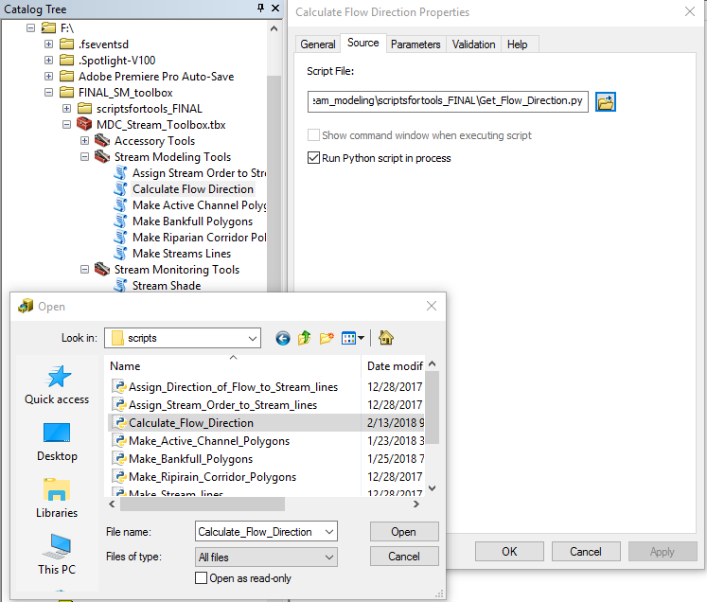

Figure 1. Point each tool to its corresponding Python script

# Setting up the Geodatabase

In ArcCatalog, create a [new File Geodatabase](https://missouriconservation.sharepoint.com/:b:/r/sites/gis/Shared%20Documents/GIS%20Quick%20Tips/GISQuickTip_CreateGBD.pdf?csf=1&e=touXX4) (Figure 2).

Name the geodatabase the same name as your study area. DO NOT USE SPACES OR SPECIAL CHARACTERS. Use underscores in place of spaces.

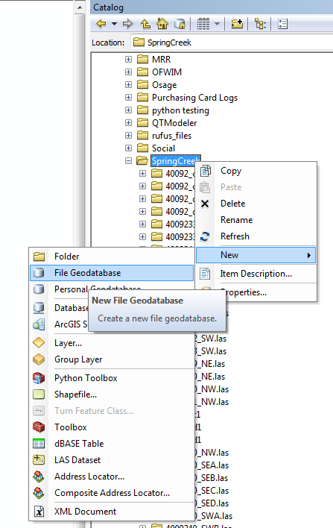

Figure 2. Create a new file geodatabase

Right click on the geodatabase that was created. Select *Make Default Geodatabase*.

*Tools*

# Create a Digital Elevation Model (DEM)

**If DEMs are available:**

Download the DEM rasters. Open the *Mosaic to New Raster* tool (Figure 3), and input the raster files. Under the Output Location field, choose the file path for your new file. Under the Raster Dataset Name with Extension field, enter the name of your new raster file*. For Pixel Type, select 32_BIT_FLOAT. Cellsize should be 1. Number of Bands should also be 1. Press OK.

\**Note: Raster names cannot exceed 13 characters. Do not begin with a number. Do not use spaces.*

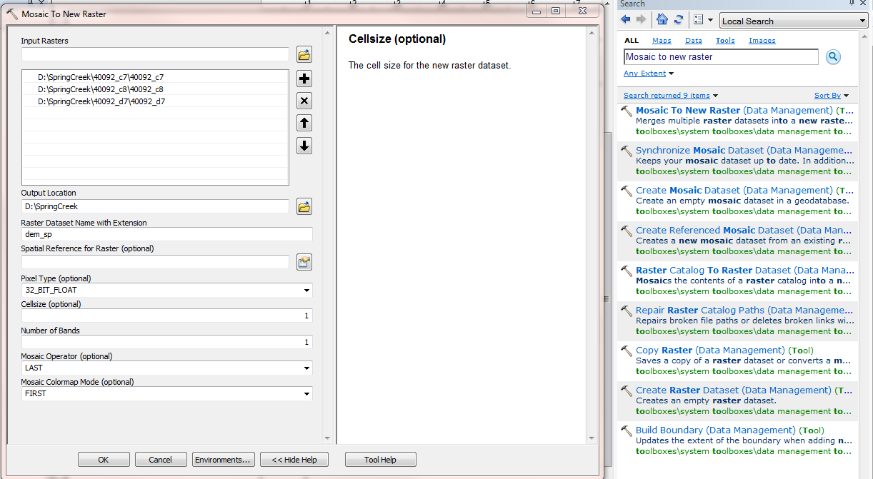

Figure 3. Mosaic to New Raster tool

# Create a Digital Elevation Model (DEM)

**If only LAS files are available:**

In ArcCatalog, create a New LAS Dataset (Figure 4).

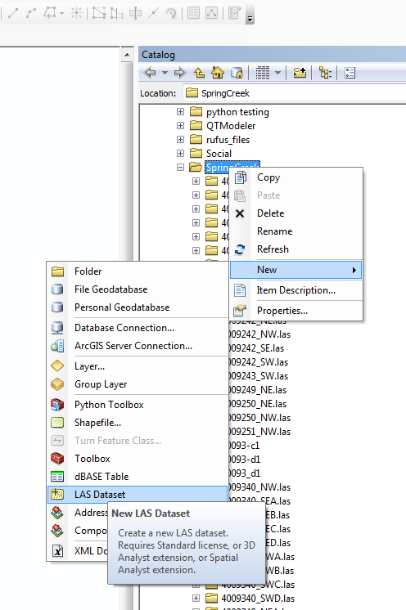

Figure 4. Create a new LAS Dataset

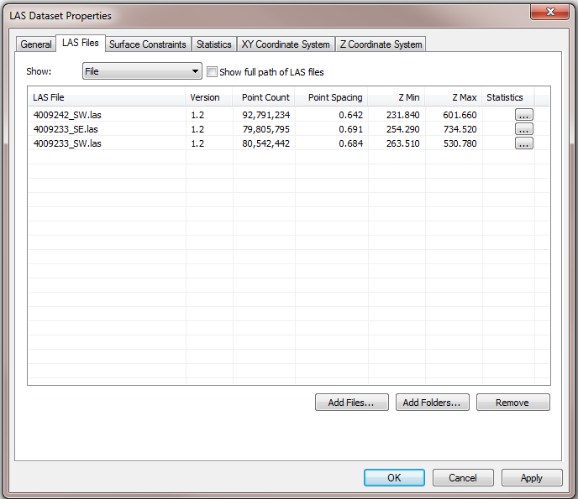Double click on the LAS Dataset to open the *LAS Dataset Properties* dialog box. Navigate to the *LAS Files* tab, and add the downloaded LAS files (Figure 5).

Figure 5. Add LAS files to the dataset

Then, navigate to the *Statistics* tab. Click *Calculate*. Press OK to close the dialog box.

[Add the LAS Dataset to the workspace](https://missouriconservation.sharepoint.com/:b:/r/sites/gis/Shared%20Documents/GIS%20Quick%20Tips/GISQuickTip_CreateGBD.pdf?csf=1&e=touXX4). Right click on the LAS layer to open the *Layer Properties* dialog box. Navigate to the *Filter* tab. Under Classification Codes, check “2 Ground” (Figure 6). Press OK.

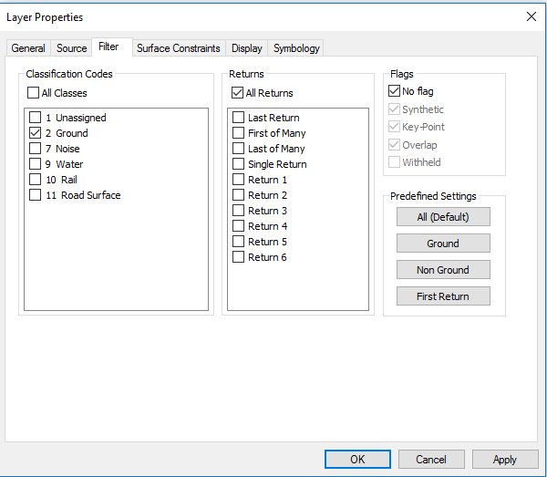

Figure 6. Filter LAS points for ground points

Open the *LAS Dataset to Raster* tool (Figure 7). Input the LAS Dataset. Under Output Raster, define the file path and name of your new raster. For the Value Field, select **ELEVATION**. Under Interpolation Type, select **Binning**. Set Cell Assignment Type to **AVERAGE**, and Void Fill Method to **NATURAL_NEIGHBOR**. Change the Sampling Value to **1**. Press OK.

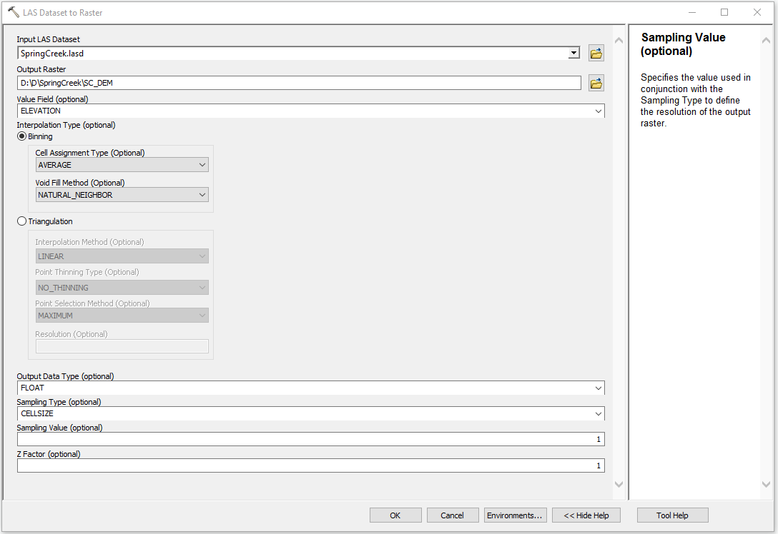

Figure 7. LAS Dataset to Raster tool for DEM

# Creating a DSM (Digital Surface Model)

Add the previously created LAS Dataset to the workspace. Right click on the LAS layer to open the *Layer Properties* dialog box. Navigate to the *Filter* tab. Under Classification Codes, confirm that the “All Classes” box is checked. Press OK. (Figure 8)

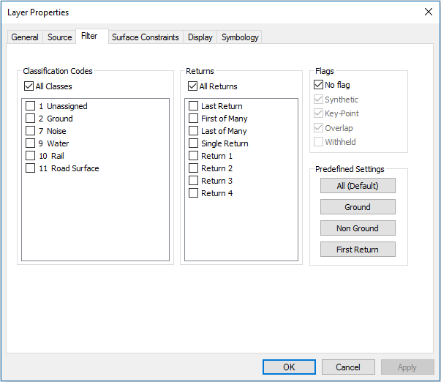

Figure 8. Unfiltered LAS points

Open the *LAS Dataset to Raster* tool. Input the LAS Dataset. Under Output Raster, define the file path and name of your new raster. For the Value Field, select ELEVATION. Under Interpolation Type, select Binning. Set Cell Assignment Type to MAXIMUM, and Void Fill Method to NATURAL_NEIGHBOR (Figure 9). Change Sampling Value to 1. Press OK.

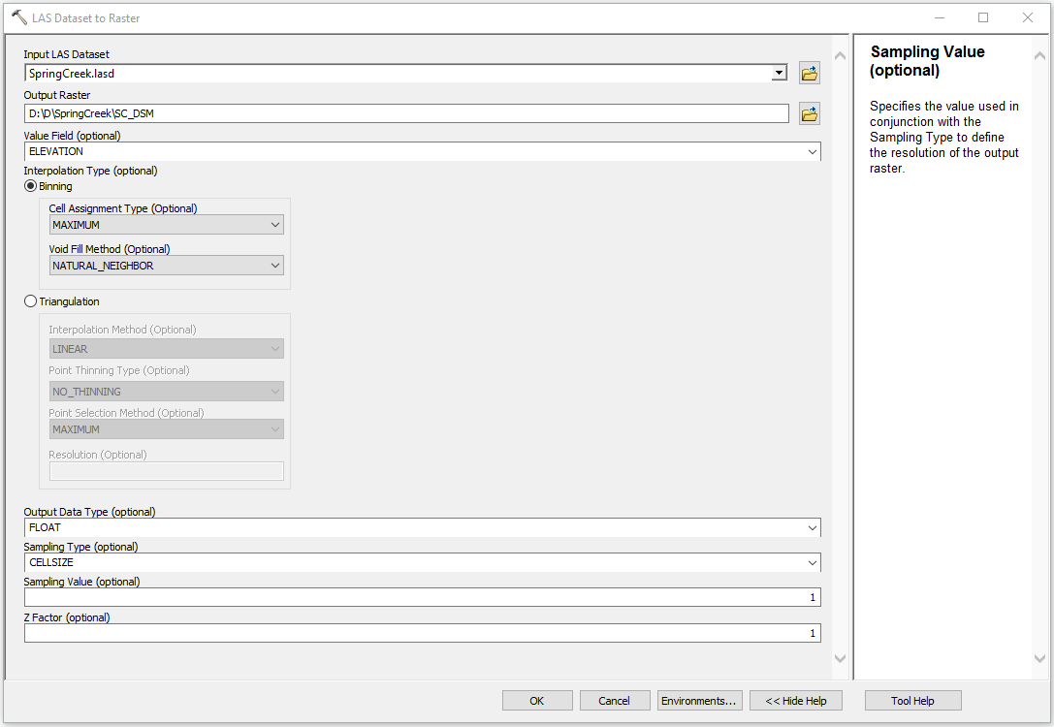

Figure 9. LAS Dataset to Raster for DSM

# Create Vegetation Height Raster

### Dependent on the DEM Tool and the DSM Tool. Run these tools first.

Creating a vegetation height raster is a two-step process that utilizes a conditional statement in the Raster Calculator.

In ArcMap, search for and open the *Raster Calculator* tool (Figure 10).

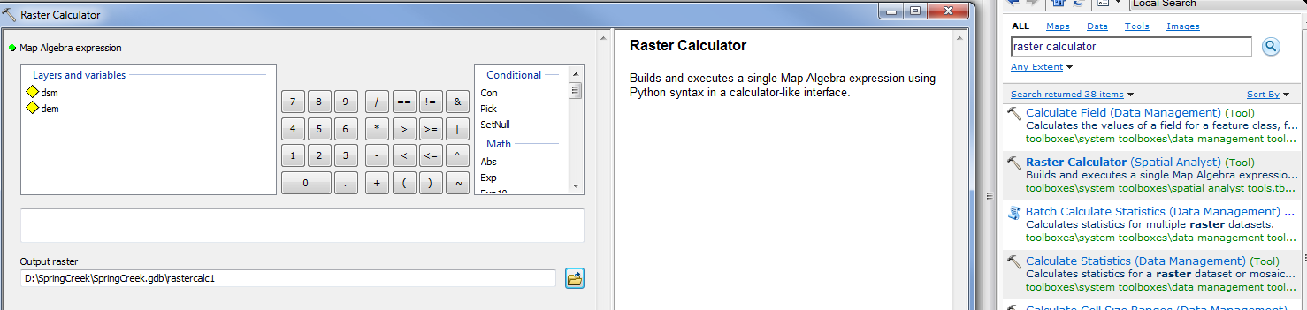

Figure 10. Search for the Raster Calculator tool

**STEP 1:**  Remove negative values from vegetation results with the following conditional statement:

*Con(("DSM" - "DEM") < 0, 0, "DSM" - "DEM")*

Create this equation by clicking on the appropriate values within the dialog box (Figure 11).   
Do not attempt to type in the equation by hand.

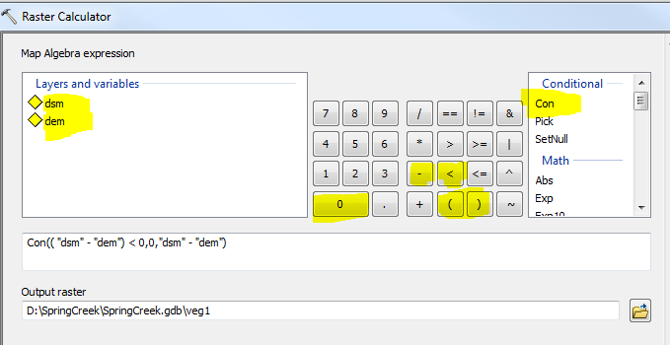

Figure 11. Conditional statement that removes negative values

**STEP 2:** Remove high false data returns by repeating the process with this equation (Figure 12):

*Con(“veg1”>100, 100, "veg1")*

*Note: By specifying the number 100, we are saying that any point greater than 100 meters above the   
 ground is assumed to be false data and should be removed.*

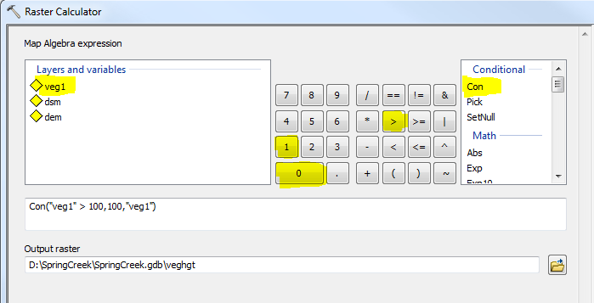

Figure 12. Conditional statement that removes outliers or high false data returns

# Aspect

### Dependent on the DEM Tool. Run this tool first.

The *Aspect* tool identifies the downslope direction of the maximum rate of change in value from each cell to its neighbors (Figure 13).

Input: DEM created from *Create DEM* process

Output: Aspect raster

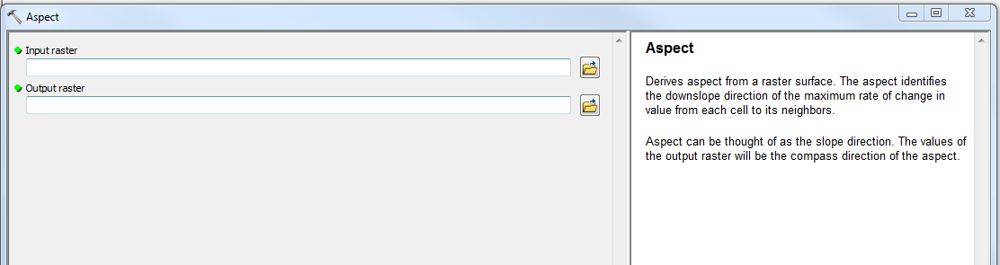

Figure 13. Aspect tool

# Hillshade

### Dependent on the DEM Tool. Run this tool first.

The *Hillshade* tool (Figure 14) creates a shaded relief from a surface raster by considering the illumination source angle and shadows. The output of this tool will be used to perform quality checks on the *Active Channel Polygons Part 2* output.

Input: DEM created from *Create DEM* process

Output: Hillshade raster

Keep defaults for remaining options.

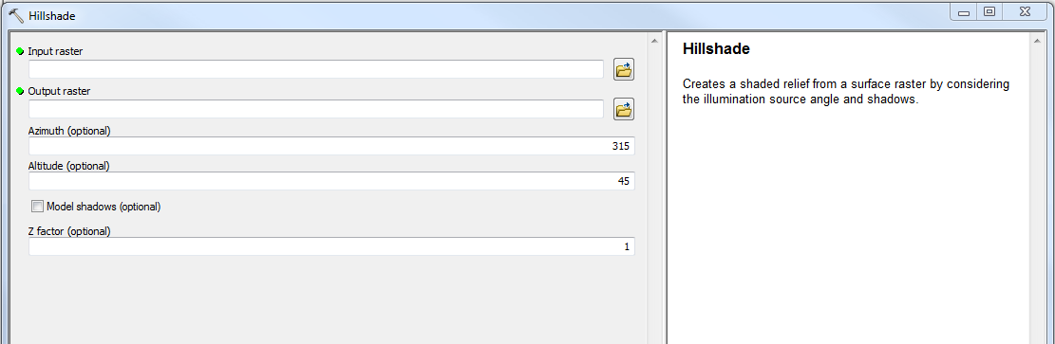

Figure 14. Hillshade tool

# Slope

### Dependent on the DEM Tool. Run this tool first.

The *Slope* tool (Figure 15) identifies the slope (gradient, or rate of maximum change in z-value) from each cell of a raster surface.

Input: DEM created by *Create DEM* process

Output: Slope raster

For the Output Measurement, specify **DEGREE**.

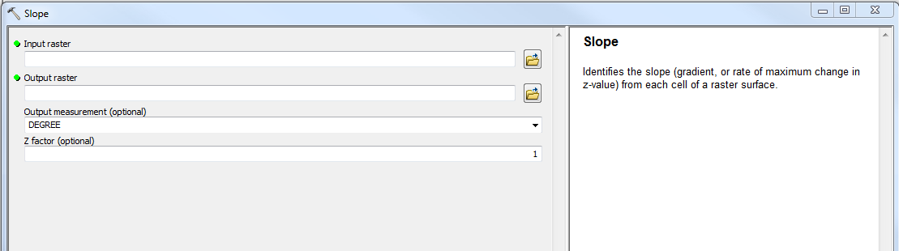

Figure 15. Slope tool

*Stream Modeling Tools*

These script tools are part of multi-script tool workflow with the goal of modeling stream lines, active channels, bankfull, and riparian corridors for all streams within an input area.

The general workflow is as follows:

**Calculate Flow Direction 🡪 Make Stream Lines 🡪 Make Active Channel Polygons 🡪 Make Bankfull Polygons 🡪 Make Riparian Corridor Polygons**

Below is a brief overview of each tool:

**Calculate Flow Direction:** Generates 2 raster files (a sink-free DEM and a flow direction raster) which are necessary inputs for subsequent tools in the workflow.

**Make Stream Lines:** Generates stream lines for the streams in the input area.

**Assign Stream Order to Stream Lines:** Writes the Strahler and Shreve stream order of each stream segment into the attribute table.

**Make Active Channel Polygons Part 1:** Sets up overhead data necessary for *Make Active Channel Polygons Part 2*.

**Make Active Channel Polygons Part 2**: Generates polygons representing the active channel for streams in the input area. This dataset is a draft.

**Make Bankfull Polygons:** Generates polygons that represent the bankfull for streams in the input area. Cleans up the draft active channel polygons dataset and outputs a finalized version.

**Make Riparian Corridor Polygons:** Generates polygons that represent the riparian corridor for streams in the input area.

*Note: Each tool will be outlined in greater detail on the pages that follow*.

# Calculate Flow Direction

### Dependent on Creating a DEM and Creating the Default Geodatabase. Do these steps first.

### Before any stream lines can be created, it is necessary to calculate the flow direction of the entire input area. But before flow direction can be calculated, the DEM for the input area must be removed of sinks. This tool (Figure 16) automates the workflow suggested by ESRI to create what is known as a Depressionless DEM. Flow direction is then calculated using the Depressionless DEM. This tool outputs both the Depressionless DEM and the flow direction raster to the output GDB. Both outputs will be necessary inputs for other tools.

### Inputs:

*DEM:* Select the DEM created by the *Create DEM* tool.

*Output GDB:* Identify a geodatabase to which the output data will be saved.

*Naming:* This acts as a prefix for the names of all output files. Its purpose is to keep the data organized and to make it easy to tell what is what, along with saving the user the inconvenience of manually naming every output.

### **Outputs**:

* (Naming)_Depressionless_DEM - a sink free Digital Elevation Model
* (Naming)_Flow_Direction - a raster representing the direction of flow from cell to cell

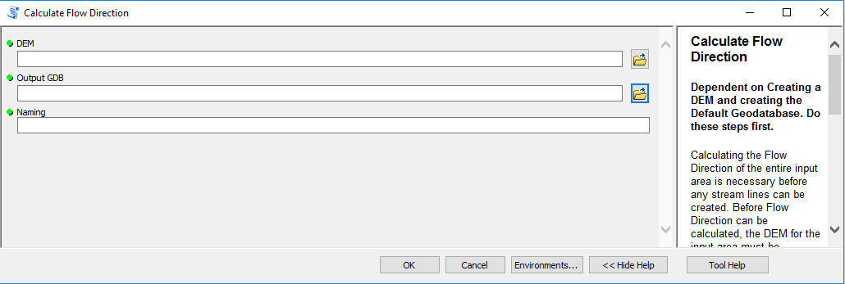

Figure 16. Calculate Flow Direction tool

**Flow Accumulation**

*Flow Accumulation* (Figure 17) is a tool developed by ESRI that outputs a raster of accumulated flow into each cell. This flow accumulation will be used to identify stream networks in the next tool.

### Inputs:

*Input flow direction raster:* Input (Naming)_Flow_Direction from the *Calculate Flow Direction* tool output.

*Output accumulation raster*: Save the output in the same geodatabase as your outputs from the *Calculate Flow Direction* tool.

*Input weight raster:* Leave this blank.

*Output Data Type:* Select **INTEGER**.

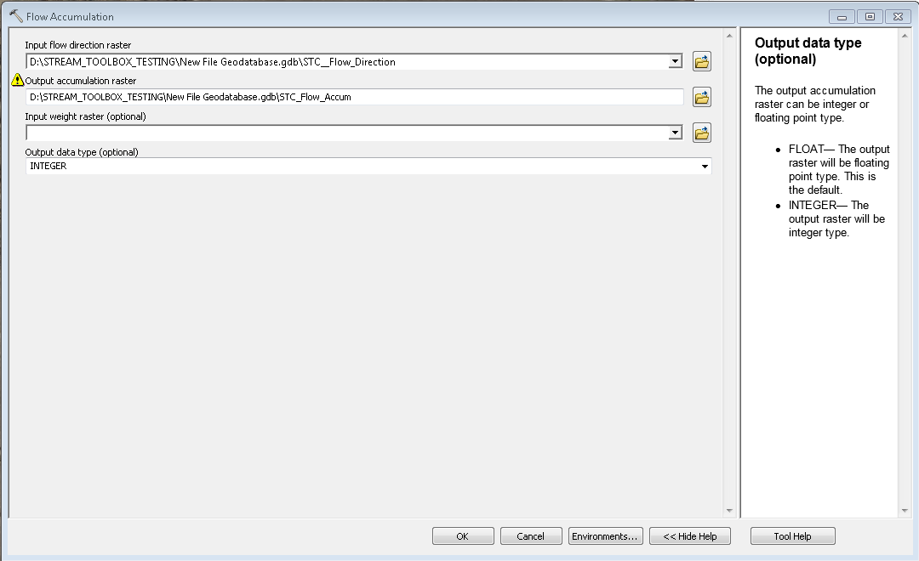

**Figure 17.** Flow Accumulation tool

# Make Stream Lines

### Dependent on the Calculate Flow Direction Tool, the Default Geodatabase, and the Flow Accumulation Tool. Run these tools first.

This tool (Figure 18) will create stream lines using the flow direction raster created by the *Calculate Flow Direction* tool and the Flow Accumulation raster created by the *Flow Accumulation* tool.

The tool’s workflow is as follows (each step is an individual ESRI ArcMap tool):

**Con(Raster Conditional) 🡪 Reclassify 🡪 Streams to Feature 🡪 Smooth Line**

**Con(Raster Conditional)** will classify all cells with values at or above the flow accumulation threshold as a 1 and the cells with values below it as a 0.

**Reclassify** will classify all cells as a 1 and all cells as 0 as NoData.

**Stream to Feature** will turn the (Naming)_(flow_x)_streams_as_raster into line data.

**Smooth Line** will smooth out sharp angles in the stream lines.

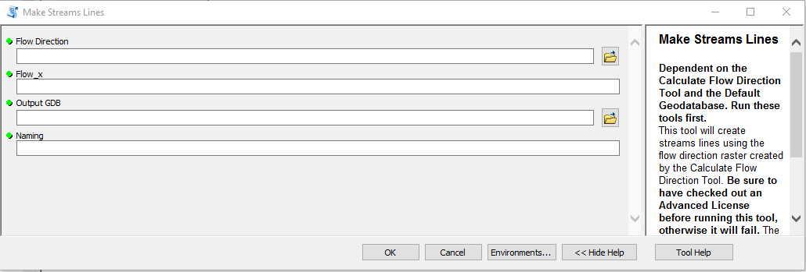

Figure 18. Make Stream Lines tool

Inputs:

*Input Flow Direction:*  Select the flow direction raster outputted by the *Calculate Flow Direction* tool -- it will be titled “(Naming)_Flow_Direction”.

*Flow_x:*  **See** ***Choosing the Correct Flow_x Value* on the next page.** This is a value that *Flow Accumulation* will use to determine the minimum flow accumulation value a cell must have before it is identified as a stream. Higher values will have fewer stream segments drawn. In other words, a higher Flow_x will result in a dataset that includes only streams that are high in stream order. A lower Flow_x will include more first order and second order streams in the dataset. The user may want to experiment to find what works best for their needs and area of interest. A good value to start at is 8000 and to experiment by increasing/decreasing in increments of 1000.

*Output GDB:*  Input a geodatabase to which the output data will be saved.

*Naming:*  This acts as a prefix for the names of all output files. Its purpose is to keep the data organized and to make it easy to tell what is what, along with saving the user the hassle of manually naming multiple outputs. The flow_x value will also be attached at the end of the naming input. Example format: “(Naming)_(flow_x)_stream_lines”

### Outputs:

* “(Naming)_(flow_x)_streams_as_raster”- raster after *Con(Flow accumulation raster)* is run through *Reclassify* tool.
* “(Naming)_(flow_x)_stream_lines”- stream lines produced by *Stream to Feature* tool and smoothed by the *Smooth Feature* tool.

**Choosing the Correct Flow_x Value:**

Flow_x is the minimum flow accumulation value a cell has to have for it to be considered part of the stream network. When the Flow_x value is too low, drainage and runoff areas that are not streams will be added to the stream network. When the Flow_x value is too high, smaller streams will be missing from the stream network. The ideal Flow_x value will vary from area to area. For this reason, it may take some experimentation to find an appropriate Flow_x value. There is no single correct value for Flow_x, but there is an appropriate range in which your value should fall so that it produces an accurate stream network.

Find this range by carefully following these steps:

1. Insert your Flow Accumulation raster into the workspace. To do this, open ArcCatalog.

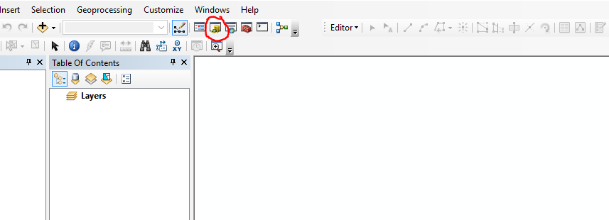

**Figure 19.** Opening ArcCatalog in ArcMap.

1. Open the geodatabase in which you saved the Flow Accumulation raster. Select the Flow Accumulation raster and drag it into the map display.

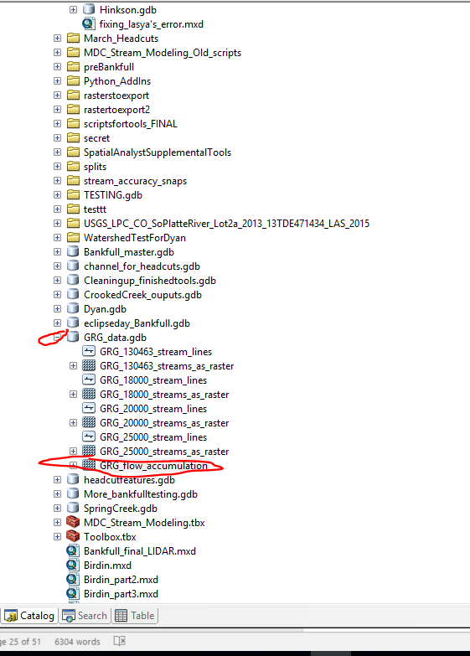

**Figure 20.** Locating the geodatabase containing the Flow Accumulation raster.

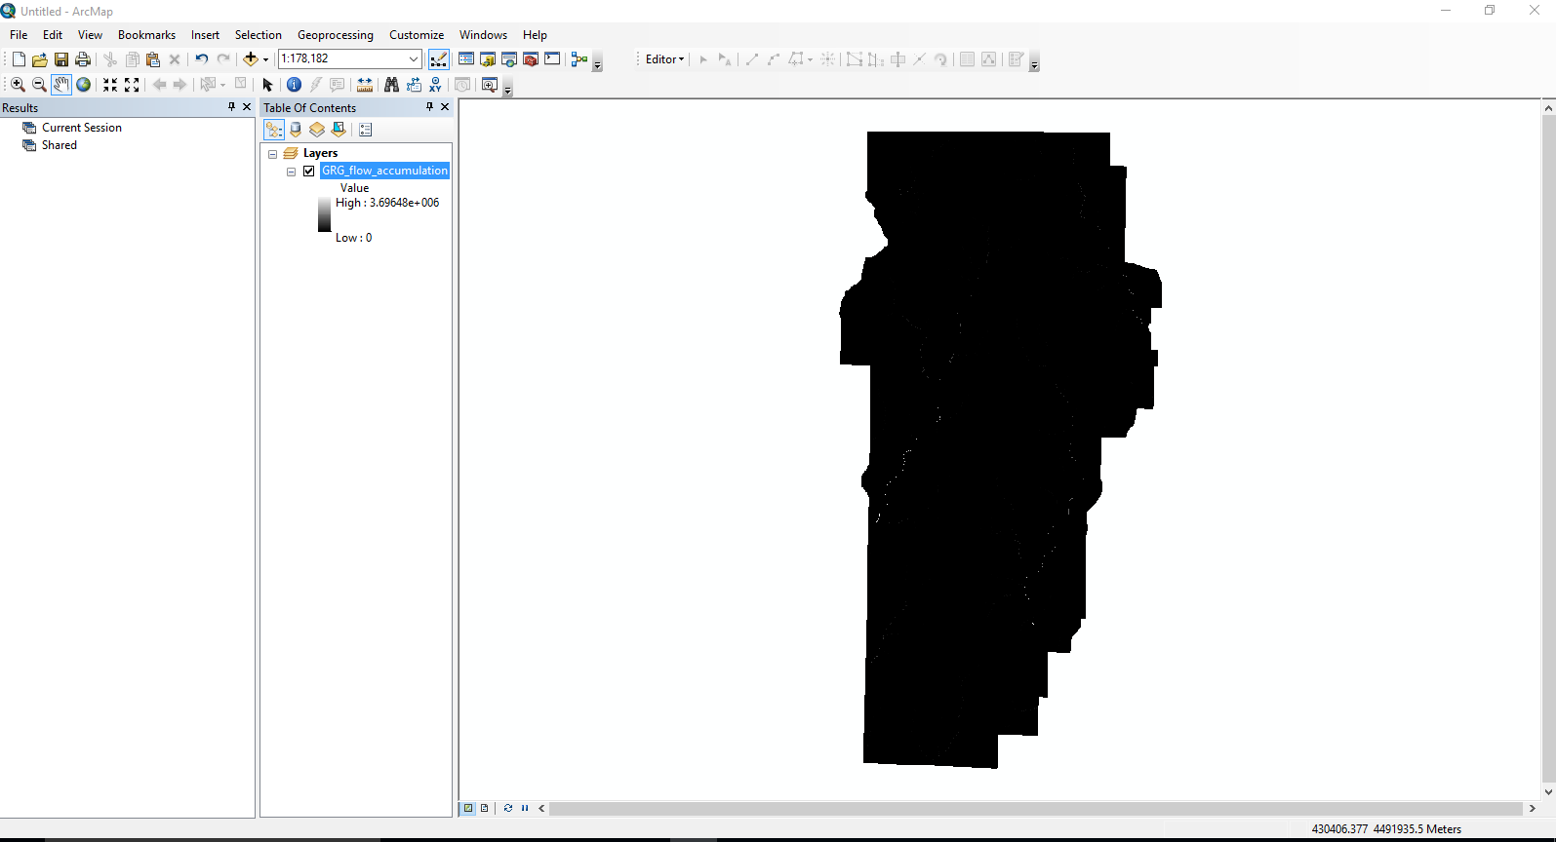

**Figure 21.** Flow Accumulation raster having been dragged into the map display.

1. Right click on the Flow Accumulation raster in the Table of Contents. Select *Properties.*

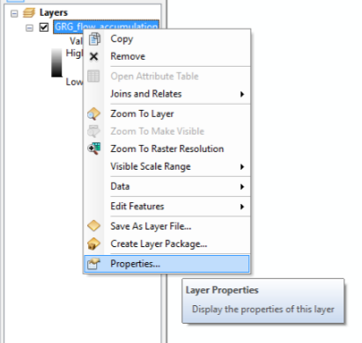

**Figure 22.** Selecting layer properties for the Flow Accumulation raster.

1. Navigate to the *Symbology* tab*.* Go to Stretch > Type. In the dropdown menu, select *Histogram Equalize*. Press Apply and close the window.

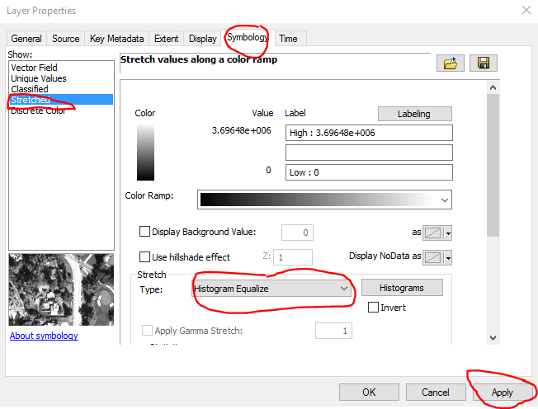

**Figure 23.** Changing layer symbology to display Histogram Equalize.

1. The stream networks will now be very easy to see in your Flow Accumulation raster.

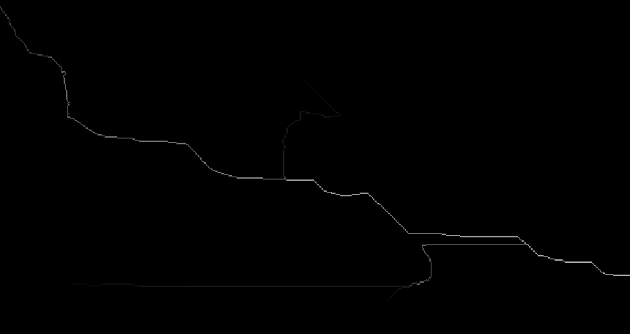

**Figure 24.** Stream networks as seen in the Flow Accumulation raster.

1. Use the identify tool in the toolbar to examine pixel values for each cell. When the identify tool is active, clicking on any cell will open a window containing the values for that cell. Notice that the pixel values of the cells in the stream network are very high compared to the values of the non-stream cells, which are very low.

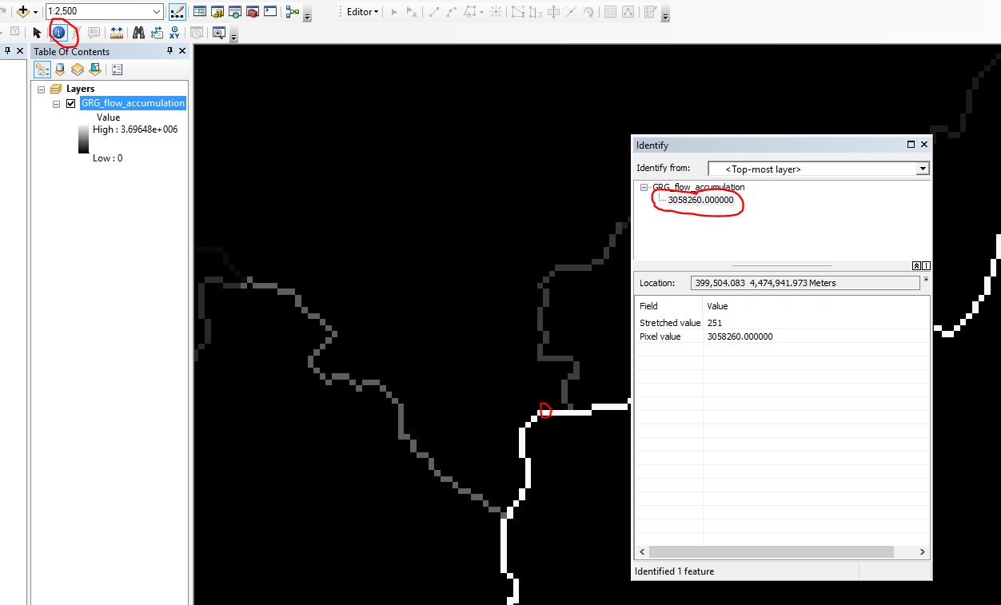

**Figure 25.**  Using the identify tool to explore pixel values within the stream network.

1. Larger streams are boldly marked and well contrasted against the black background. We can be confident that these stream lines are actually part of the stream network. However, you will also notice faintly defined stream lines. These are less likely to be actual streams, so it is strongly recommended to spot-check 5 to 10 lines to visually confirm if they are streams.

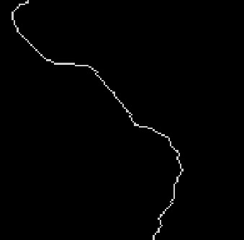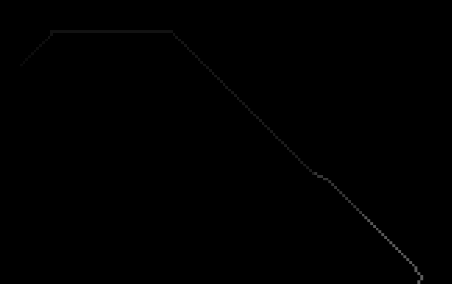

Figure 26. An example of a stream line in the Flow Accumulation raster likely to be a stream (left) and a possible false stream (right).

1. Add a basemap to your viewer to confirm presence of streams for questionable lines in the Flow Accumulation raster. Alternatively, you can process a Hillshade raster (see the *Hillshade* tool) for same purpose.

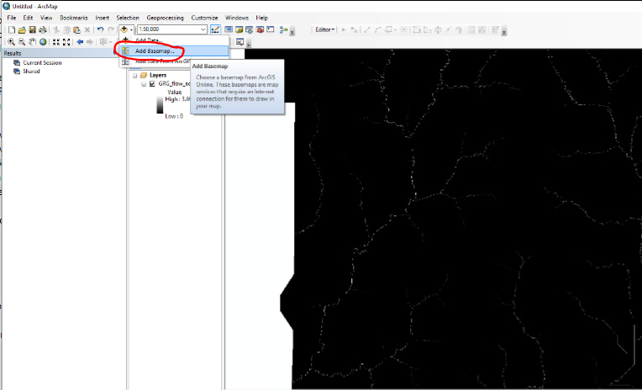

Figure 27. Adding basemap data to the workspace.

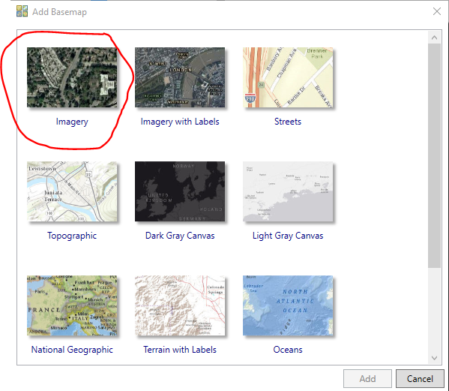

Figure 28. Adding imagery to the workspace as a basemap.

1. Examine the faintly drawn stream lines in the Flow Accumulation raster. Then, flip to the imagery basemap by unchecking the Flow Accumulation raster in the Table of Contents. If the faint lines are not streams, note the cell values of these cells with the identify tool (step 5).
2. When running the *Make Stream Lines* tool, your Flow_x needs to be just higherthan the values of these false streams. Repeat this for 5 to 10 faint streamlines. After which, you should have a good idea of how high to set your Flow_x value. Remember the idea is to set the Flow_x value just high enough so that these drainage/runoff areas are not collected. For example, if I examine 5 faint stream lines on my Flow Accumulation raster and I see the values 50,000, 52,000, 51,000, 55,000, I would set my Flow_x to about 56,000. This value is high enough to prevent these faint lines from being added to the stream network without being so high that actual streams are excluded from the stream network.

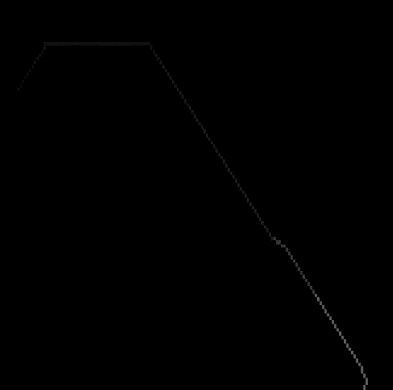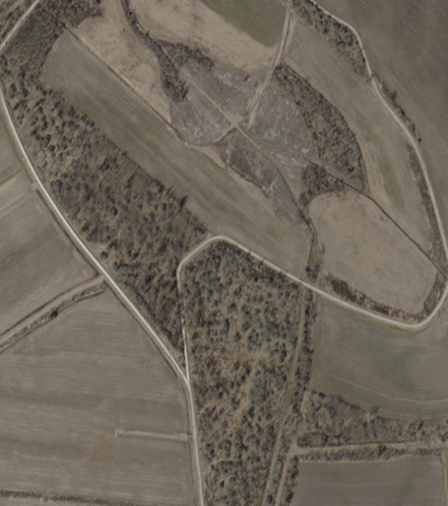

Figure 29. An example of a false stream in the Flow Accumulation compared to imagery confirming that the line does not represent an actual stream.

1. Run the *Make Stream Lines* tool. Compare your output stream lines to the imagery basemap. Make sure there are no streams lines where there are no streams. If your Flow_x was too low or too high, simply rerun the tool, adjusting the Flow_x accordingly.

# A Note About Errors Using Make Stream Lines

### When comparing the output against a Hillshade or DEM, you will notice that most of the stream lines created by the *Make Stream Lines* tool will match up with areas appearing to be stream beds. However, you may also notice that some lines diverge slightly from the actual stream bed (Figure 30). Recall how the *Calculate Flow Direction* tool uses a Depressionless DEM to fill in sinks and other errors on the original DEM that would prevent a stream network from being able to be created. Occasionally, this process may also inadvertently fill in streams that are less defined, although this usually only happens with first order streams. Unfortunately, there is no way to automatically correct this.

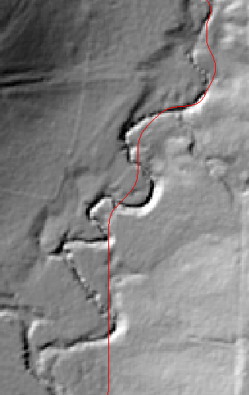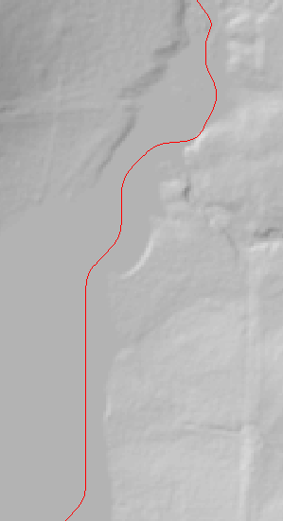

Figure 30. An output of the Make Stream Lines tool compared to Hillshade from the original DEM (left)   
and from the Depressionless DEM (right).

# Assign Stream Order to Lines

### Requires an Advanced license. Dependent on the Make Stream Lines Tool. Run this tool first.

This tool (Figure 31) will determine the Strahler and Shreve Stream Order of each stream segment and assign it to a field in the stream line attribute table. The results can be accessed by right clicking on the feature class in the Table of Contents and clicking on *Open Attribute Table* (Figure 32). Strahler and Shreve Stream Order are two systems for classifying streams based on their number of tributaries. Although ArcGIS comes with a Stream Order tool, it only outputs a raster which makes it difficult to run analysis on vector data, such as stream lines.

### 

Figure 31. Assign Stream Order to Stream Lines tool

### Inputs:

*Stream Lines:* Select the stream lines outputted by the *Make Stream Lines* tool (“(Naming)_(flow_x)_stream_lines”).

*Stream Raster:* Select the raster outputted by the *Make Stream Lines* tool that has a value only where there is a stream present “(Naming)_(flow_x)_stream_as_raster)”.

*Flow Direction:* Select the flow direction raster outputted by the *Calculate Flow Direction* tool (should be named “(Naming)_Filled_Flow”).

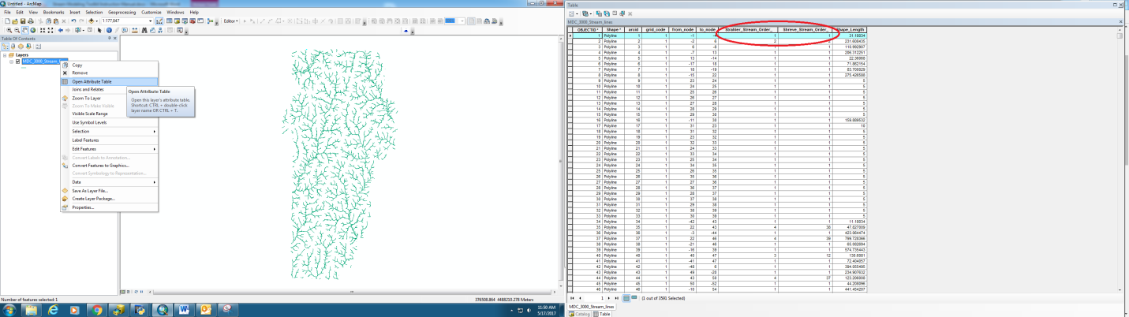

Figure 32. Locating Strahler and Shreve fields in the attribute table

### *Note: The tool can only assign stream orders with 100% accuracy to streams in watersheds that are fully contained within the input area of interest or have all of their first order streams in the stream line dataset. For example, if the Digital Elevation Model used to create the stream lines contains only half of a given watershed, then the stream lines in that watershed maybe be assigned stream orders that are inaccurate because not all of the streams were present to allow for an accurate calculation.*

**Make Active Channel Polygons**

### Requires an Advanced license, and a Default Geodatabase. Dependent on the Calculate Flow Direction, Make Stream Lines, and Assign Stream Order to Lines. Run these tools first.

This tool outputs polygons that represent active channel for streams in the input area by using elevation values from the input DEM. The polygons are essentially the area of the stream between the stream banks. This means there may not necessarily be water where these polygons are; these polygons are more of a representation of the stream bed. The areas identified as active channels are extracted into polygons (“(Naming)_AC_polys_draft”). You will notice that these polygons are labeled “draft.” Although the active channels are successfully identified, the tool has a tendency to sometimes over extract areas that are not actually inside the stream bed. The next tool in the workflow (*Make Bankfull Polygons*) will clean up the draft active channel polygons, eliminating some of the over extracted areas. These cleaned polygons will be the final active channel polygons for the input area.

The Make Active Channel Polygons tool is divided into 2 separate tools. The first tool *Make Active Channel Polygons Part 1* takes care of processing all the overhead data necessary to identify the active channel, while *Part 2* identifies and extracts these areas as polygons. *Part 1* may take awhile to finish running, depending on the size of the input dataset. Be patient. Once *Part 1* is completed, *Part 2* runs much more quickly.

**Make Active Channel Polygons Part 1** (Figure 33)**:**

Make Active Channel Polygons Part 1 will do all the overhead data processing and output the data to a large point file called “(Naming)_dempoints_wattr.” This will be the input to Part 2.

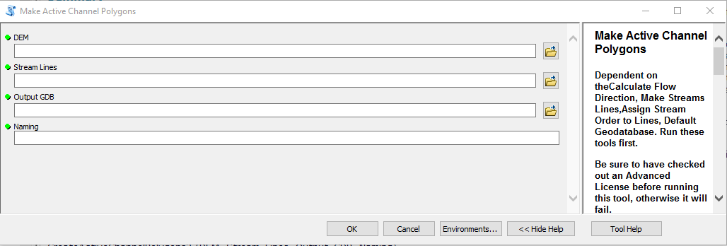

Figure 33. Make Active Channel Polygons Part 1 tool

**Inputs:**

*DEM:* Select the original DEM. **NOT THE DEPRESSIONLESS DEM.**

*Stream Lines:* Select the stream lines created by the *Make Stream Lines* tool (“(Naming)_(flow_x)_Stream_Lines”).

*Output GDB:* Input a geodatabase to which the output data will be saved.

*Naming:* This input acts as prefix for the names of all output files. Its purpose is to keep the data organized and make it easy to tell what is what, along with saving the user the hassle of manually naming multiple outputs.

**Outputs:**

* “(Naming)_dempoints_wattr”- A very large point file that has a point for every pixel within a distance of the input streamlines. These points have all the data needed to identify active channel attached to their attribute table.

**Make Active Channel Polygons Part 2:**

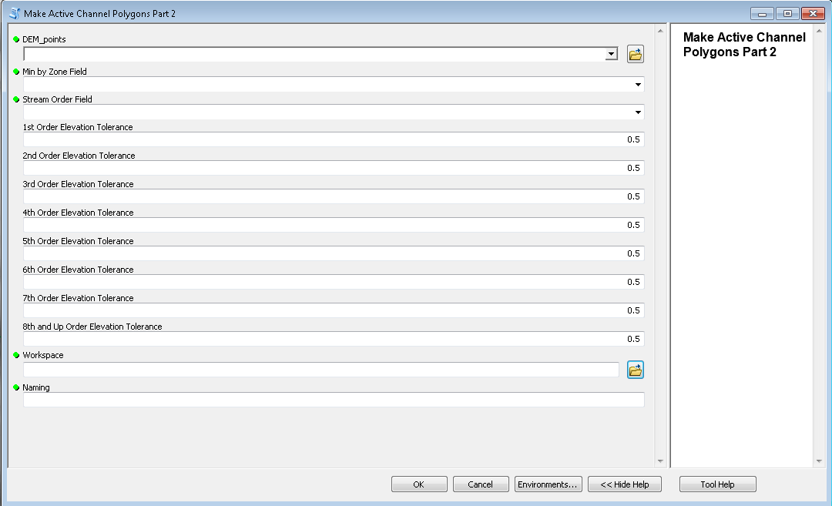**Figure 34.** Make Active Channel Polygons Part 2 tool

### Inputs:

*DEM:* Select the same DEM you used for Make Active Channel Polygons Part 1.

*DEM points:* Select the points outputted by the *Make Active Channel Polygons Part 1* tool (“(Naming)_(dempoints_wattr”).

*Min by Zone Field:* Select “(Naming)_min_by_zone” from the drop-down menu.

*Stream Order Field:* Select “(Naming)_SOraster” from the drop-down menu.

*Stream Order Elevation Tolerance Fields:* Leave these at the default (0.5) on the first run of this tool. These will only get manipulated if the output stream polygons from the first run of the tool were inaccurate and the user is running the tool a second time to fix these inaccuracies. **See Active Channel Polygon Quality Checking on the following pages for more details.**

*Output GDB:* Input a geodatabase to which the output data will be saved.

*Naming:* This input acts as prefix for the names of all output files. Its purpose is to keep the data organized and make it easy to tell what is what, along with saving the user the hassle of manually naming multiple outputs.

**Outputs:**

* “(Naming)_AC_polys_draft”- Polygons representing the active channel of each stream segment. These are not the final active channel polygons. These polygons will be cleansed of some over extractions later with the *Make Bankfull Polygons* tool.   
  **Be sure to quality check this output. See Active Channel Polygon Quality Checking below for more details.**

**Active Channel Polygon Quality Checking:**

*Part 2* requires some quality checking from the user to assess the appropriateness of the Stream Order Elevation Tolerance parameters. The default for each stream order rank is 0.5 meters. Try these default values in the first run of *Make Active Channel Polygons Part 2* and then construct a Hillshade raster (do this by running the *Hillshade* tool on the input DEM) to help verify the quality of your results.

Below are some examples of what the output polygons will look like when a suitable elevation tolerance for the input area is used. Notice how the polygons are mostly continuous and that the stream does not bleed out onto the banks. Unfortunately, in some geographies you will not be able to create a completely gapless output without streams bleeding out beyond the banks.

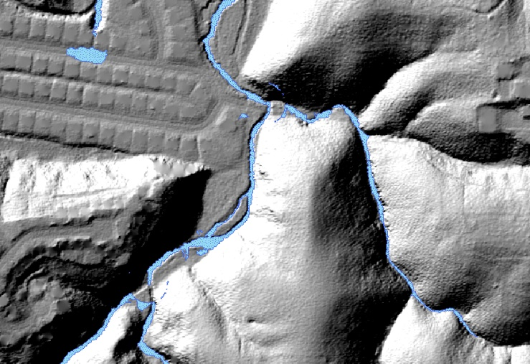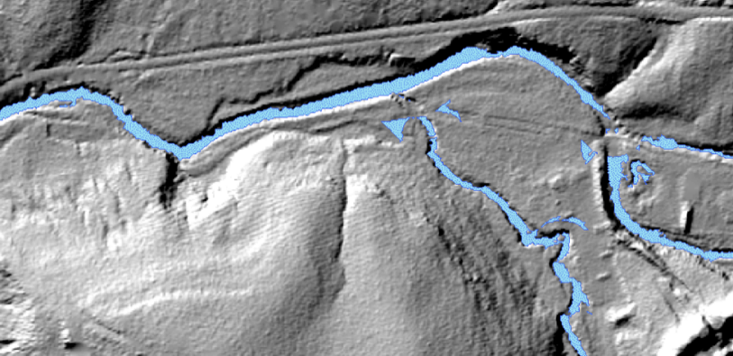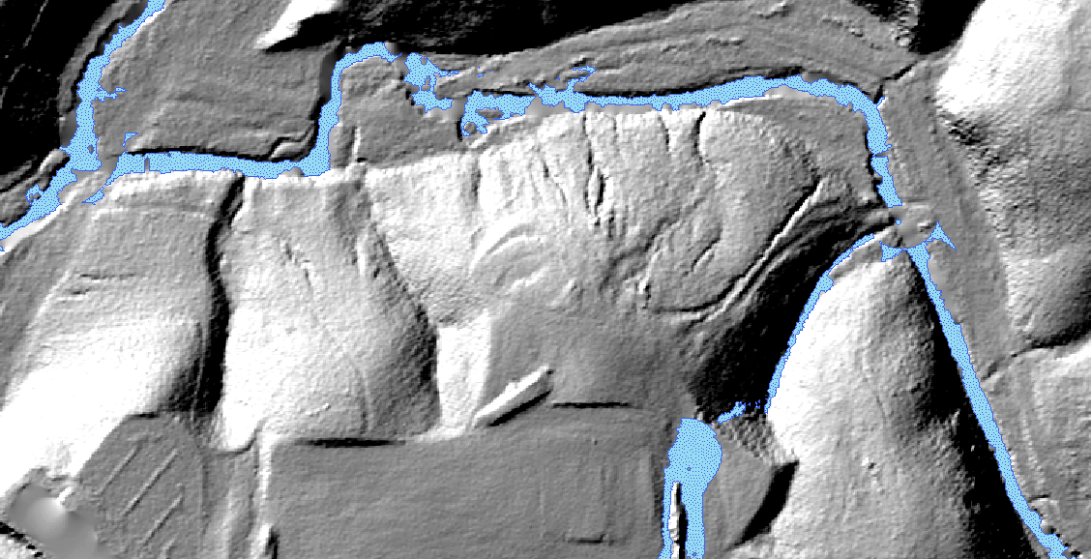

**Figure 35.** Examples of Active Channel Polygons generated with suitable elevation tolerances.

Elevation Tolerance Too Low:

Below are examples of what the output looks like when the elevation tolerance is too low. Notice the frequent fragmentation throughout the data. Much of the stream bed has not been extracted.

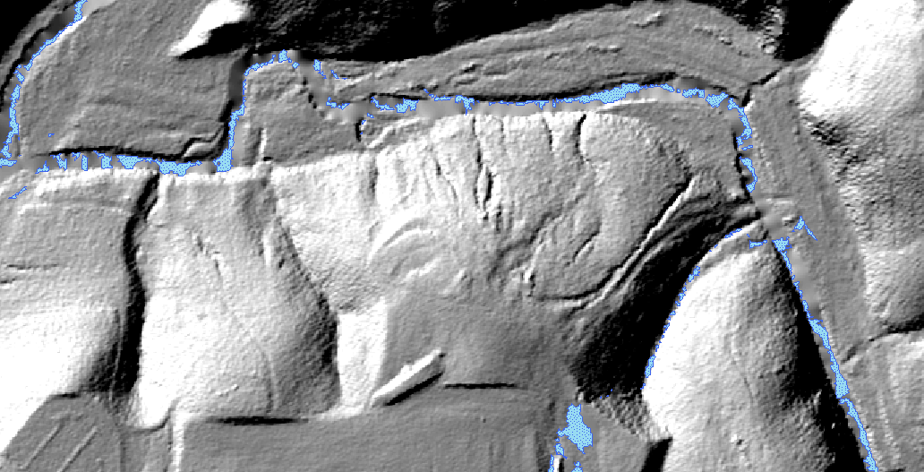

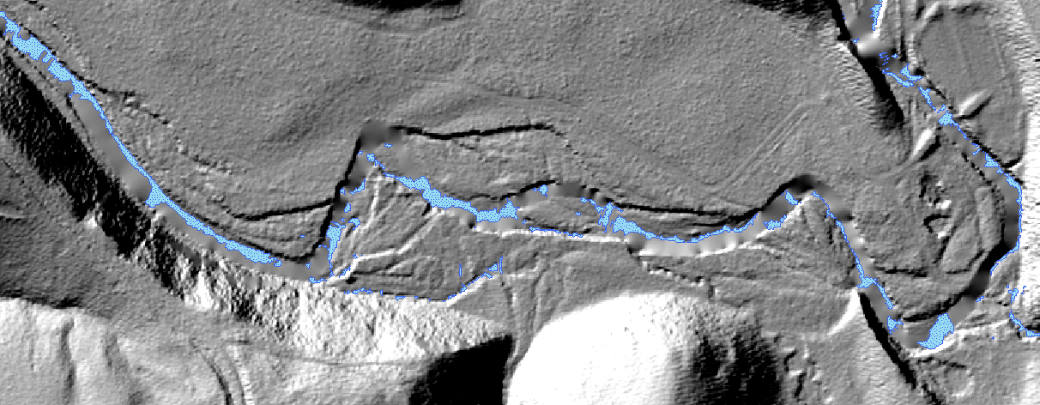

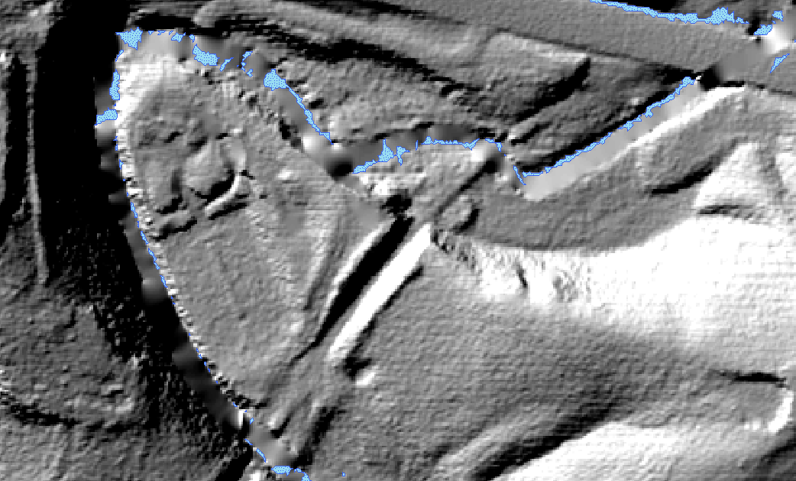

**Figure 36.** Examples of Active Channel Polygons generated with elevation tolerances that were too low.

Example of Elevation Tolerance Too High:

Below is an example of when the Elevation Tolerance is too high. Notice that the output Active Channel Polygons (outlined in blue) extend beyond the stream bed.

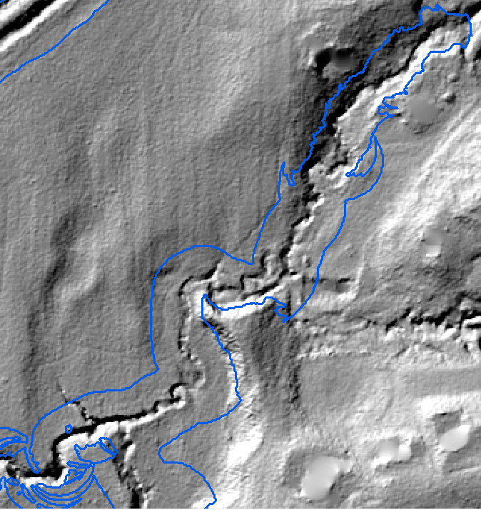

**Figure 37.** Examples of Active Channel Polygons generated with elevation tolerances that were too high.

What to do when output stream polygons show signs of having an elevation tolerance that is too low or too high:

First, determine the stream order rank for the streams that were inaccurately extracted by consulting the entries in the attribute table of the stream lines feature class ((Naming)_(flow_x)_streamlines)) that corresponds to the inaccurate polygons. The field you are looking for is “Strahler_Stream_Order_”. Once you have the stream order rank of the inaccurate stream bed(s), rerun *Active Channel Polygons Part 2* with the same inputs as before but either increase or decrease the value of elevation tolerance for the corresponding stream order. For example, if it appeared that most of my 5th order streams were under extracted, when rerunning the tool I would change the parameter *5th Order Elevation Tolerance* from 0.5 to 1. I would then quality check the results of the rerun. If the 5th order streams were still under extracted, I would increase the elevation tolerance for that stream order from 1 to 1.5. This process would be repeated until I finally have the appearance of accurate active channel polygons.

In contrast, if it appeared that mostly 2nd order streams were over extracted (polygons bleeding out of the stream bed), in my rerun of *Make Active Channel Polygons Part 2* I would decrease my 2nd Order Elevation tolerance from 0.5 to 0.25 or 0.

# A Note About Errors Using Make Active Channel Polygons

You may notice small gaps occurring infrequently along channels that are particularly narrow and meandering (Figure 38). This is normal and unfortunately, there is no way to fix this. While annoying, these errors are very minor and should not be significant enough to affect the accuracy of any of the stream monitoring tools.

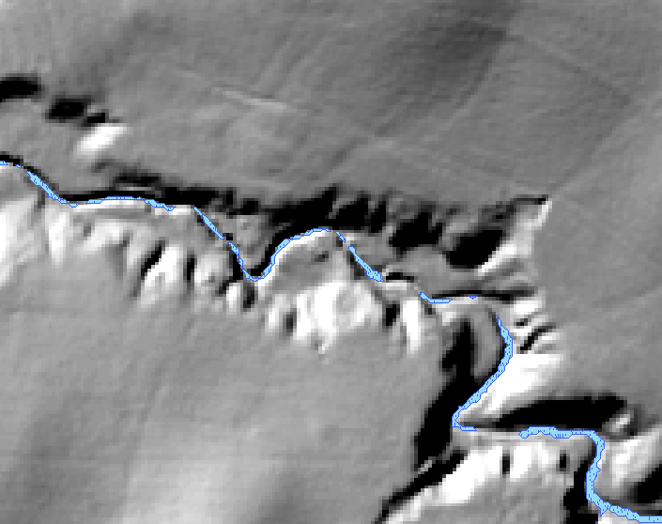

Figure 38. Small gaps caused by narrow and meandering channels

Very large gaps (Figure 39) may occur when stream lines are misdrawn far away from their actual locations. *For more information on why this error occurs see:* A Note About Errors using Make Stream Line.

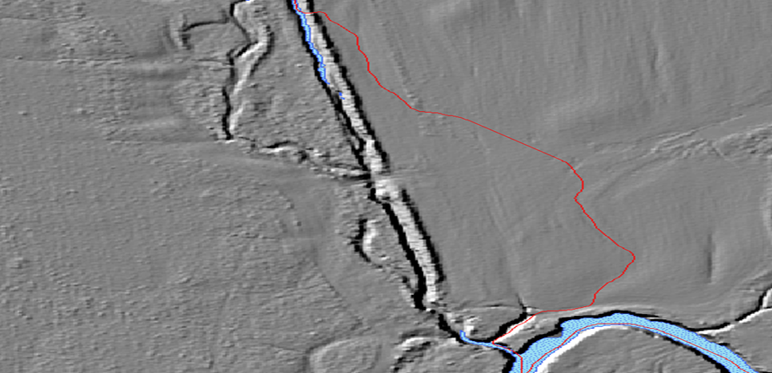

Figure 39. Large gaps occur when Make Stream Lines draws stream lines far from actual channel

The *Make Stream Lines* tool may also extract stream lines from flat surfaces that have no actual streams. The *Make Active Channel Polygons* tool extracts areas around the stream lines based on elevation change. Because little to no elevation change occurs across flat surfaces, the tool may also incorrectly extract the flat area around a misdrawn line as a stream (Figure 40).

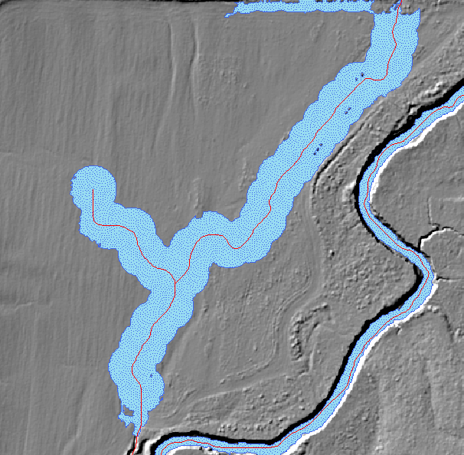

Figure 40. Over extraction error on misdrawn stream lines

The user may also notice small polygons that are outside of the stream bed (Figure 41). Remember that the output from this tool is considered a draft dataset. Most, if not all, of these types of errors will be deleted from the final version once run through the *Make Bankfull* tool.

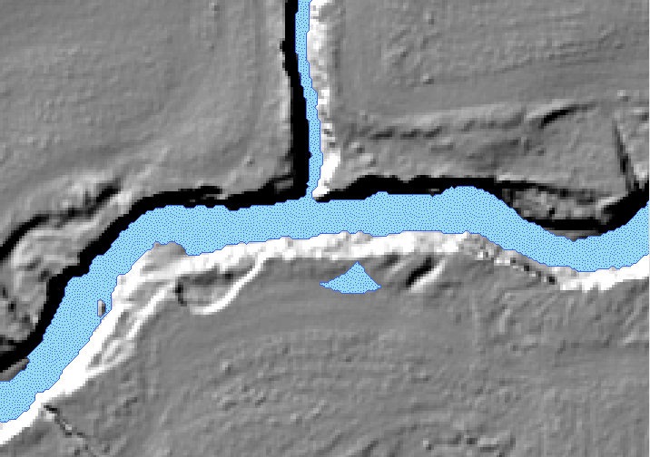

Figure 41. Over extraction error in draft version of Active Channel Polygons

Stream channels may occasionally run into lakes or reservoirs. Since this tool was only made to extract stream channels, it will not be able extract these features accurately. When this error occurs, the user will notice circular active channel polygons (Figure 42).

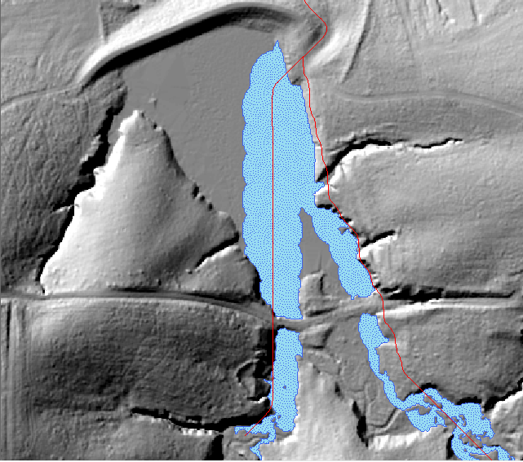

Figure 42. Lake/reservoir error

**Make Bankfull Polygons**

**Requires an Advanced License.  
Dependent on Make Active Channel Polygons, and Slope. Run these first.**

This tool (Figure 43) will create bankfull polygons by looking for hard slope breaks that are adjacent to the input active channel polygons. It will also clean up the draft version of the input active channel polygons dataset and output a final version along with the bankfull polygons.

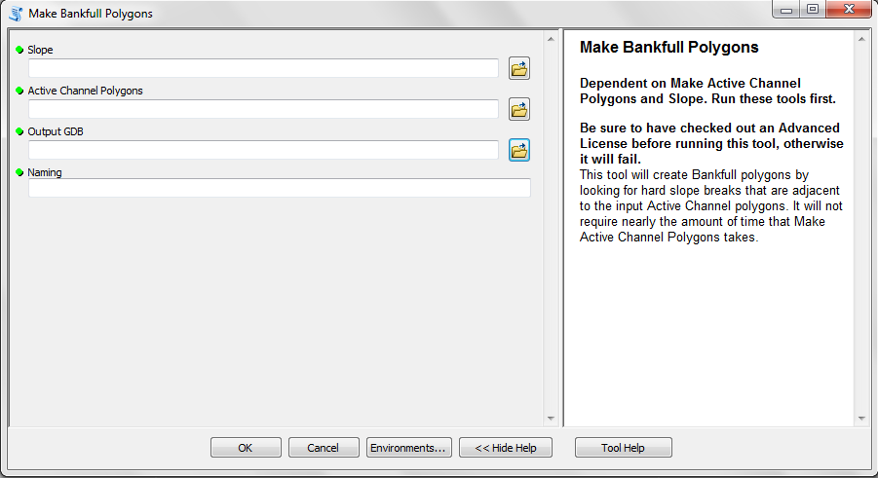

Figure 43. Make Bankfull Polygons tool

**Inputs:**

*Slope:* Select the slope raster that was created by the *Slope* tool. **BE SURE THAT SLOPE WAS RUN ON THE ORIGINAL DEM, NOT THE DEPRESSIONLESS DEM.**  If the slope of the Depressionless DEM is the input, then the output bankfull polygons will be flawed.

*Streamlines:* Select the streamlines created by the *Make Streams Lines* tool “(Naming)_(flow_x)_stream_lines”.

*Active Channel Polygons:* Select the active channel polygons created by the *Make Active Channel Polygons* tool (“(Naming)_AC_polys_draft”)

*Output GDB:* Input a geodatabase to which the output data will be saved.

*Naming:* This acts as a prefix for the names of all output files. Its purpose is to keep the data organized and make it easy to tell what is what, along with saving the user the hassle of naming many different outputs manually.

**Outputs:**

* “(Naming)_Bankfull_Polygons” - Polygons representing the bankfull of each stream segment.
* “(Naming)_Active_Channel_polys_FINAL” - Polygons representing the cleaned active channel of each stream segment removed of some over extractions.

**Make Riparian Corridor Polygons**

**Dependent on Make Bankfull Polygons tool. Run this tool first.**

This tool (Figure 44) will create riparian corridor polygons for each stream segment by placing a 30-meter buffer around each segment’s bankfull polygons.

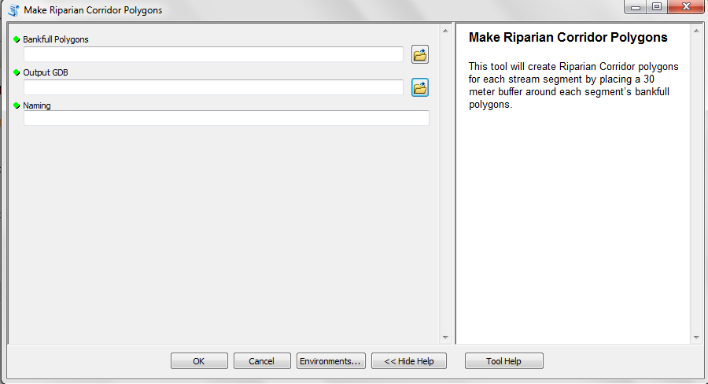

Figure 44. Make Riparian Corridor Polygons tool

**Inputs:**

*Bankfull Polygons:* Select the bankfull polygons created by the *Make Bankfull Polygons* tool (“(Naming)_Bankfull_polys_FINAL”).

*Output GDB:* Input a geodatabase to which the output data will be saved.

*Naming:*  This acts as a prefix for the names of all output files. Its purpose is to keep the data organized and make it easy to tell what is what, along with saving the user the hassle of manually naming multiple outputs.

**Outputs:**

* “(Naming)_Riparian_Corridors” - Polygons representing the riparian corridor of each stream segment. There will only be one polygon per set of contiguous streams. If you want individual polygons segmented by stream segment, run this output through the *Stream Shade* tool. If you want them segmented by watershed or catchment, run it through the *Vegetation Stats By Catchment* tool.

*Stream Monitoring Tools*

These script tools can be used to monitor the health of streams. They do not have to be run in any particular order.

Below is a brief overview of each tool:

**Stream Shade by Segment**: Calculates the percentage of shaded and non-shaded for each stream segment.

**Vegetation Stats By Catchment**: Calculates the percentage of canopy, understory, and bare ground making up each catchment or watershed.

*Note: Each tool will be outlined in greater detail on the pages that follow*.

# Stream Shade by Segment

### Dependent on Make Bankfull tool, Creating a Vegetation Height Raster.

The *Stream Shade* tool (Figure 45) will calculate the percentage that each stream segment an area of interest is shaded. The tool outputs a polygon feature class that is the input active channel polygons segmented by stream segment. Each active channel polygon will have the percentage of shaded and unshaded in the attribute table. Unshaded areas are classified as areas with ground cover less than 0.5 meters tall and shaded areas are classified as all other areas.  The tool also outputs a raster called “(Naming)_Shaded_vs_Unshaded” for user reference.

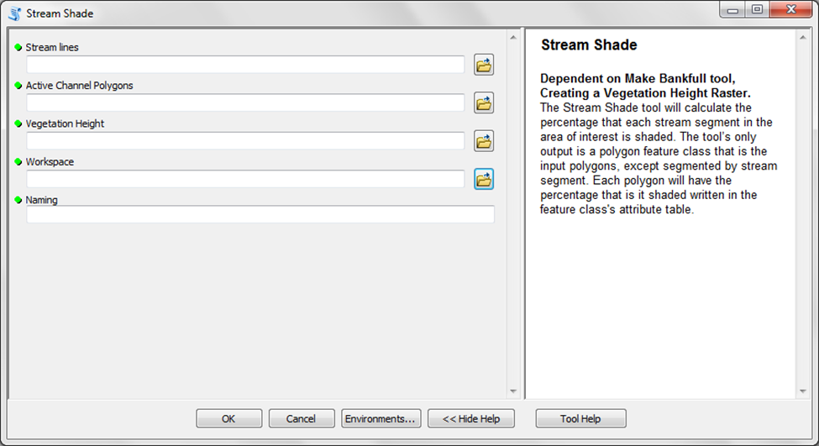 Figure 45. Stream Shade tool

### Inputs:

*Stream lines -* Use the stream lines made by the *Make Stream Lines* tool (“(Naming)_(flow_x)_stream_lines”).

*Active Channel Polygons -* Use the active channel polygons (“(Naming)_Active_Channel_polys_FINAL”). The bankfull polygons and riparian corridor polygons are also valid inputs if the user is curious about their percent shaded.

*Vegetation Height -* Input the vegetation height raster.

*Workspace -* Input a geodatabase to which the output data will be saved.

*Naming -* This acts as a prefix for the names of all output files. Its purpose is to keep the data organized and make it easy to tell what is what.

### Outputs:

(Naming)_polys_with_StreamShade - The input bankfull polygons will now be segmented by stream segment and be associated with a field called “Percent_Shaded.” They will be saved to the output GDB.

(Naming)­_Shaded_vs_Unshaded - A raster dataset with a code of 1 for shaded areas and a code of 0 for unshaded areas.

# Vegetation Stats by Catchment

### Dependent on Bankfull, Make Stream Lines, and Creating a Vegetation Height Raster.

This tool (Figure 46) outputs vegetation cover statistics for the input area’s streams into a new feature class called “(Naming)_polys_with_Veg_Stat”. This is done by segmenting the polygons outputted by the Bankfull tool by catchment and calculating what percentage of each catchment is covered in canopy, understory, and bare earth (ground). The results are included in the output’s attribute table. Ground is defined as vegetation less than 0.5 meters, understory is 0.5–4.9 meters, and canopy is anything 5 meters and above. The tool also outputs one raster representing each type of ground cover for user reference.

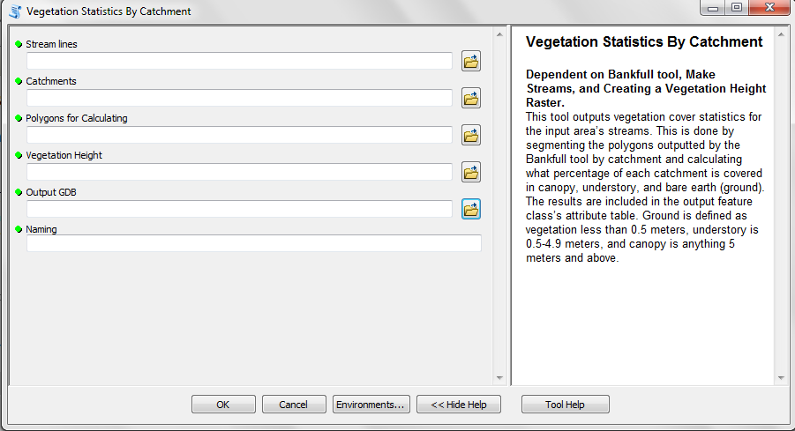

**Figure 46.** Vegetation Statistics by Catchment tool

**Inputs:**

*Stream lines* - Use the stream lines made by the *Make Stream Lines* tool (“(Naming)_(flow_x)_stream_lines”).

*Catchments* - Input a polygon feature class that represents catchments for the area of interest. Watersheds or any other type of polygon feature class that segments the stream lines in the input area will also work.

*Polygons for Calculating* - Use either the active channel polygons, the bankfull polygons, or the riparian corridor polygons.

*Vegetation Height* - Input the vegetation height raster.

*Output GDB* - Input a geodatabase to which the output data will be saved.

*Naming* - This acts as a prefix for the names of all output files. Its purpose is to keep the data organized and make it easy to tell what is what.

**Outputs:**

(Naming)_polys_with_Veg_Stat - The input bankfull polygons will now be segmented by catchment and will contain fields named “Percent_Ground,” “Percent_Under,” and “Percent Over” attached to the attribute table. These fields represent what percentage each polygon is covered in each type of vegetation. The new feature class will be saved to the output GDB.

(Naming)_bareground - A raster dataset with a code of 1 for bareground areas (less than 0.5 meters) and a code of 0 for all other areas.

(Naming)_understory - A raster dataset with a code of 1 for understory areas (0.5–5 meters) and a code of 0 for all other areas.

(Naming)_overstory - A raster dataset with a code of 1 for overstory areas (above 5 meters) and a code of 0 for all other areas.

*Stream Attribute Tools*

These tools can be used to write additional attributes to each stream line in the stream line feature class’s attribute table. **They are not necessary for the Stream Modeling or Stream Monitoring workflow**. They are included in the toolbox simply to provide the user with additional information on each stream segment that may be useful.

Below is a brief overview of each tool:

**Assign Flow Direction to Lines**: Writes the general direction each stream segment is flowing into the attribute table.

**Sinuosity**: Writes the sinuosity index of each stream segment into the attribute table.

*Note: Each tool will be outlined in greater detail on the pages that follow*.

# Assign Direction of Flow to Lines

This tool assigns the cardinal direction of flow to each stream segment. The results will be outputted to the input dataset’s attribute table, which can be accessed by right clicking the feature class in the Table of Contents and clicking on *Open Attribute Table* (Figure 47). The new field will be labeled “Direction_of_Flow.”

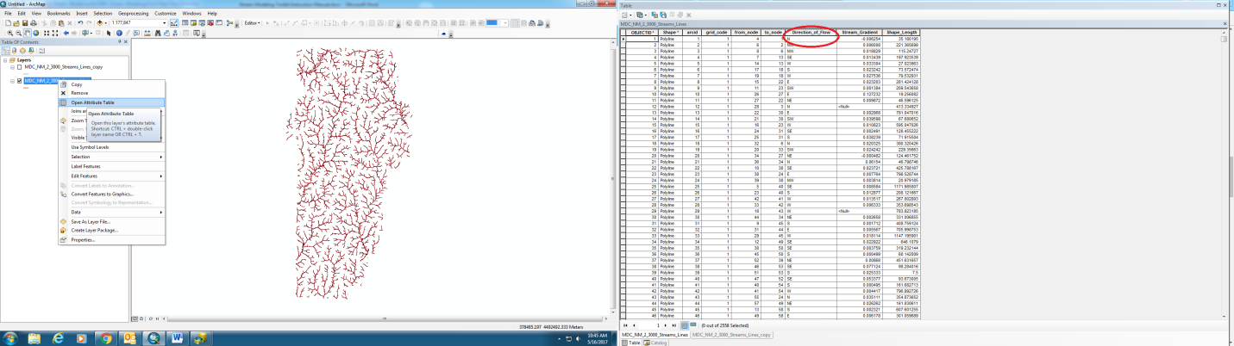

Figure 47. Flow Direction field in the attribute table

### Inputs: (Figure 48)

*Stream Lines:* Select the stream lines outputted by the Make Stream Lines tool (“(Naming)_(flow_x)_stream_lines”).

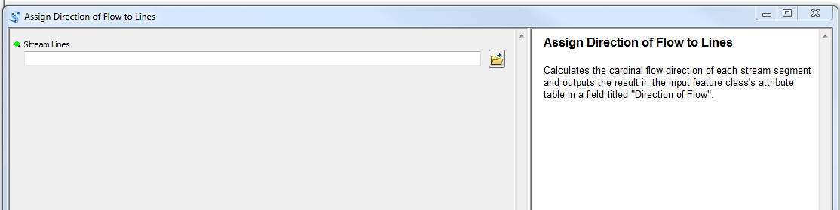

Figure 48. Assign Direction of Flow to Lines tool

# Sinuosity

This tool was developed by ESRI so it is included in a separate toolbox in the *Stream Modeling* folder titled *Sinuosity* (Figure 49). The tool is also [available for download here.](https://www.arcgis.com/home/item.html?id=00e708a448b74810a0e805c4a97f9d46)

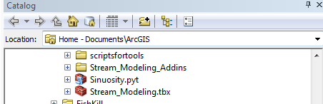

Figure 49. Sinuosity Toolbox

Sinuosity measures the deviation of a line from the shortest path. It is calculated by dividing the total length by the shortest possible path. A perfect straight stream will have a sinuosity of 1. A particularly curvy segment will have a sinuosity closer to 0.

**For the input feature class, select the stream lines outputted by the *Make Stream Lines* tool (“(Naming)_(flow_x)_stream_lines”).**

Sinuosity will be calculated for each stream segment and outputted to the attribute table under a field named “Sinuosity” (Figure 50).

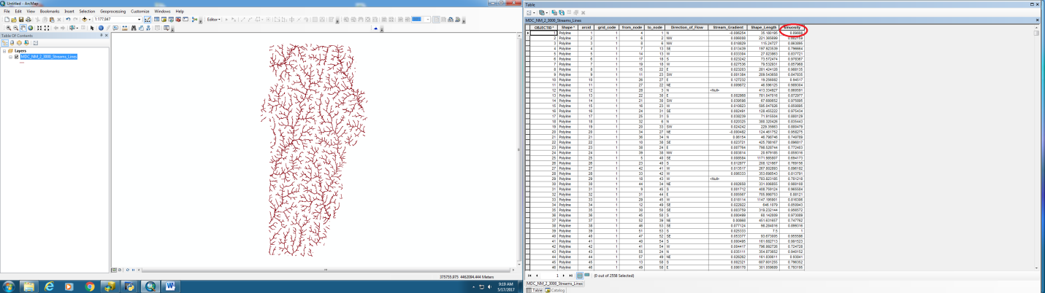

Figure 50. Attribute table showing Sinuosity field